Phase Diagram Worksheet

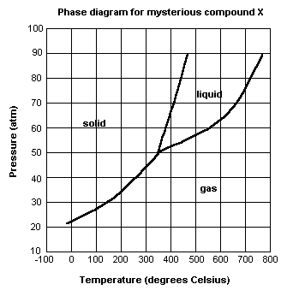For each of the questions on this worksheet, refer to the phase diagram for mysterious compound X.
1) What is the critical temperature of compound X? ___________

2) If you were to have a bottle containing compound X in your closet, what phase would it most likely be in?
_____________________

3) At what temperature and pressure will all three phases coexist?

_____________________________________

4) If I have a bottle of compound X at a pressure of 45 atm and temperature of 100⁰ C, what will happen if I raise the temperature to 400⁰ C?

_____________________________________

5) Why can’t compound X be boiled at a temperature of 200⁰ C?

_____________________________________

6) If I wanted to, could I drink compound X?

_____________________________________
Phase Diagram Worksheet

For each of the questions on this worksheet, refer to the phase diagram for mysterious compound X.
1) What is the critical temperature of compound X? ~770⁰ C

2) If you were to have a bottle containing compound X in your closet, what phase would it most likely be in?

Extrapolating from this diagram, it’s most likely a gas.

3) At what temperature and pressure will all three phases coexist?

350⁰ C, ~51 atm

4) If I have a bottle of compound X at a pressure of 45 atm and temperature of 100⁰ C, what will happen if I raise the temperature to 400⁰ C?

It will sublime

5) Why can’t compound X be boiled at a temperature of 200⁰ C?

It does not form a liquid at this temperature. It only exists as a liquid at temperatures above 350⁰ C.

6) If I wanted to, could I drink compound X?

No. At the temperatures and pressures that it forms a liquid, you’d probably die.

