Organic Compound Naming Worksheet

Write the name of each of the following organic compounds:

1)
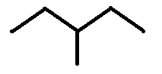

2)
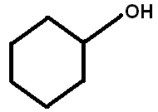

3)
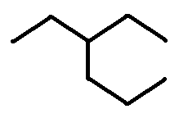

Write the structures for the following organic molecules:

4) methylcyclopentane

5) 2-ethyl-2-pentene

6) diethylamine

Organic Compound Naming Worksheet - Answers

Write the name of each of the following organic compounds:

1) 3-methylpentane

2) cyclohexanol

3) 3-ethylhexane

Write the structures for the following organic molecules:

4) methylcyclopentane
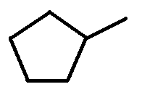

5) 2-ethyl-2-pentene
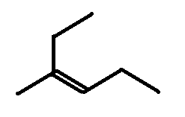

6) diethylamine
