Resonance Structures Practice

Draw all of the possible resonance structures for the following ions or molecules:

1) nitrate ion:

2) formate ion (CHO₂⁻¹):

3) cyclobutadiene (C₄H₄):

4) ozone (O₃):
Resonance Structures Practice

Draw all of the possible resonance structures for the following ions or molecules:

1) nitrate ion:
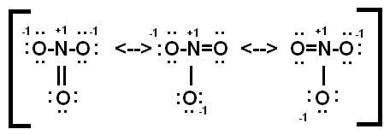

2) formate ion (CHO₂⁻¹):

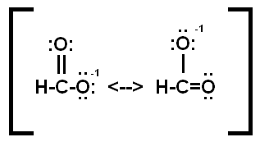
3) cyclobutadiene (C₄H₄):
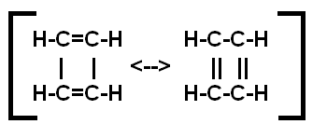
4) ozone (O₃):
